**Gram Panchayat – FARIDPUR**

Completion Certificate

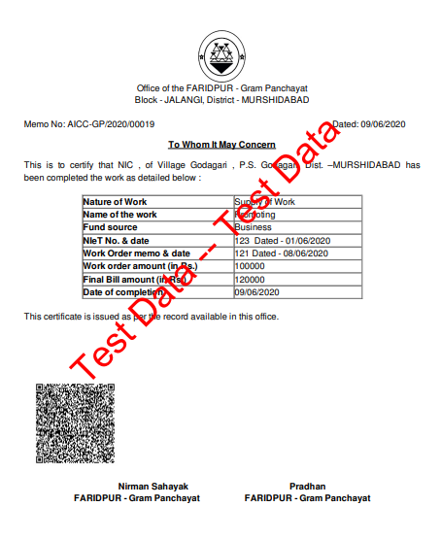

Income Certificate

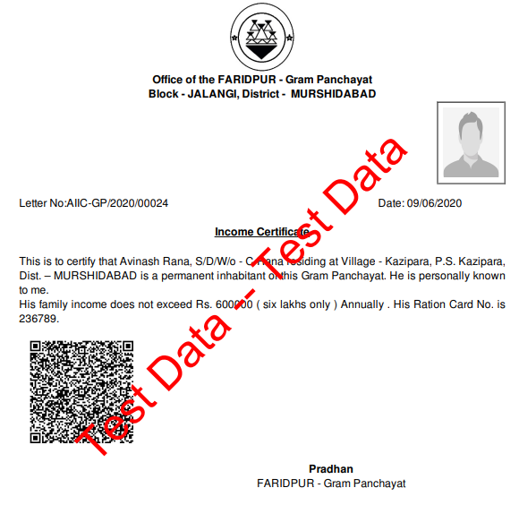

**Gram Panchayat – GHOSHPARA**

Residential Certificate

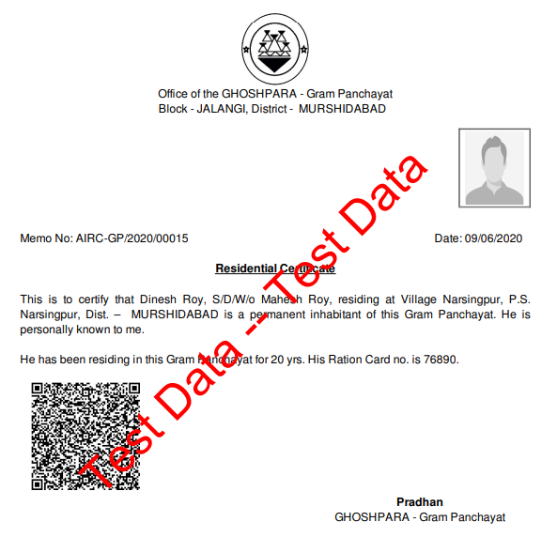

Legal Heir Certificate

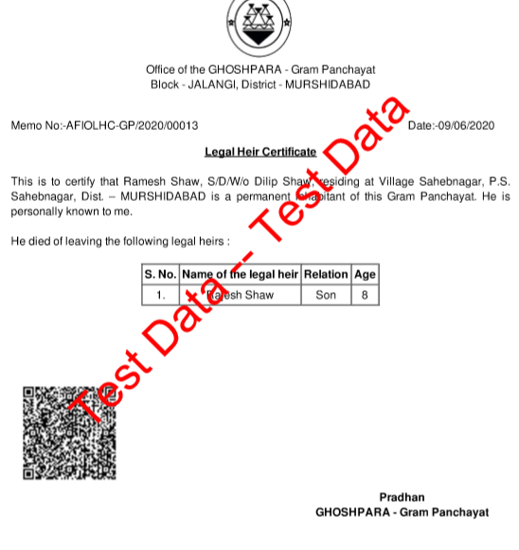

**Gram Panchayat – KATABARI**

**Completion Certificate**

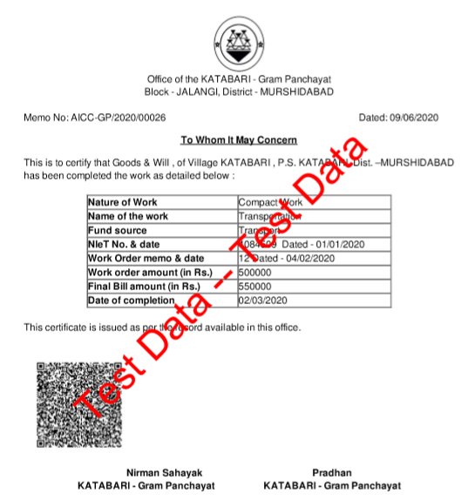

Income Certificate

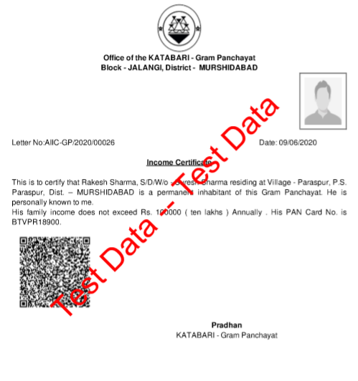

**Gram Panchayat – KHAYRAMARI**

Residential Certificate

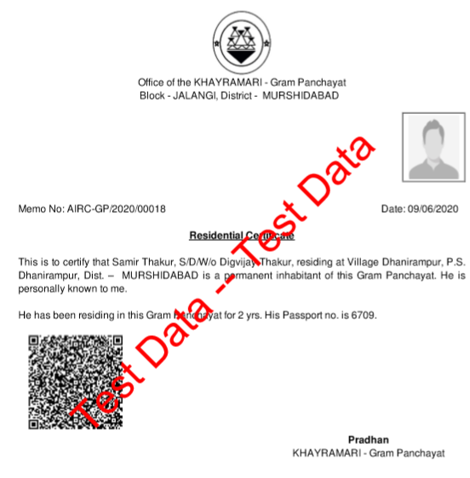

**Gram Panchayat – SADIKHANDERAH**

Completion Certificate

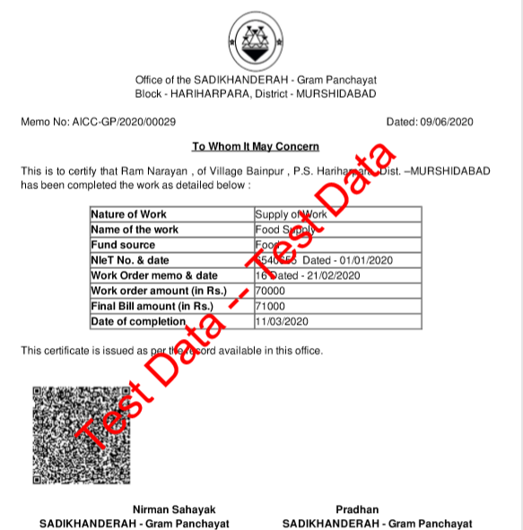

Income Certificate

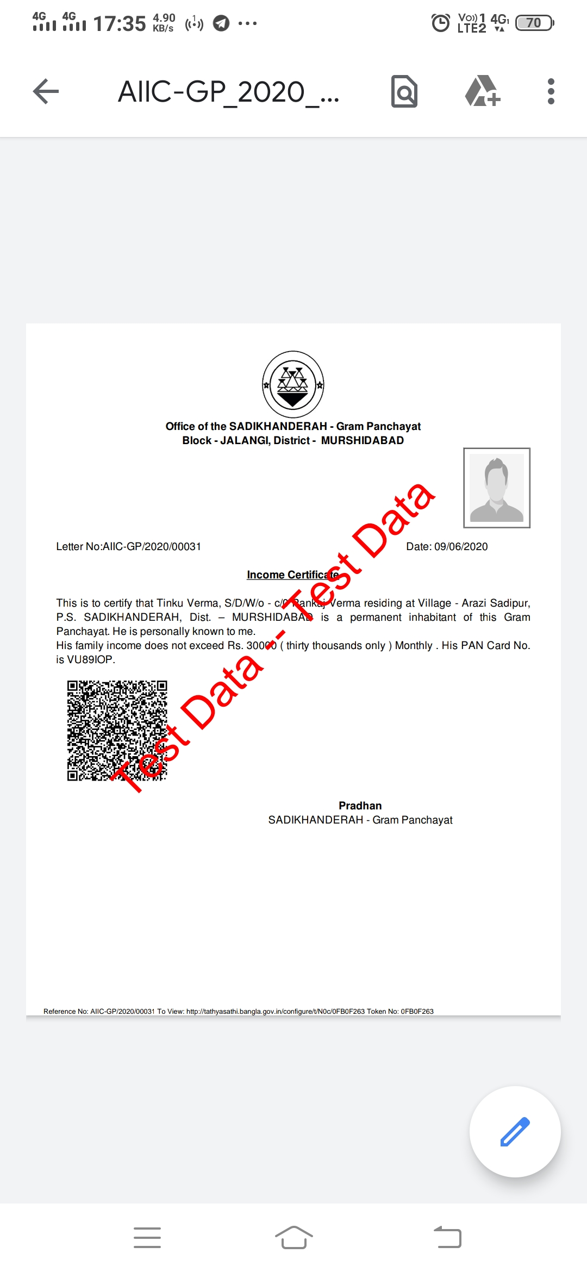

**Gram Panchayat – SAGARPARA**

Legal Heir

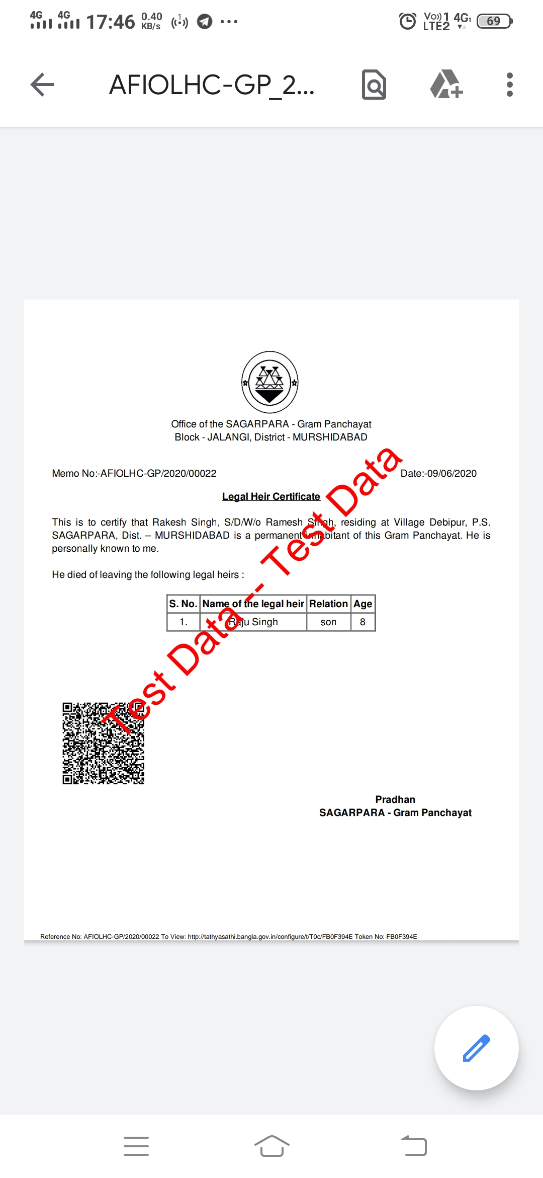

**Residential Certificate**

